St. Thomas Church Split Rail Fence
Eagle Project
By: [Eagle Candidate Name]
Donations Given by:
Bill and Christy Brasington
Harold and Carrie Bickley
Harry and Gloria Freeman
Bobby Koon
Richard Lindler
Ronnie and Ginny Lindler
The Lombardo Family
Grandmom and Pop Mills
Robert Rennebaum Family
Meme and Gramps Rennebaum
Bill and Melveta Sandel
Marie Stoudemire
Betty and Jennings Wessinger
Lee Wessinger
With Special Thanks to:
Mr. Hal Bickley
Mr. Carl and Chris Lindler
Mr. Albert Stoudemire
Pastor Larry Hagerty
St. Thomas Church congregation
Many volunteers who put in countless hours of hard work
Invocation …………………….….…….………Pastor [enter name]
Pastor, [church name]

Opening ……………………………...….Scoutmaster [enter name]

Introduction of Keynote Speaker…....Scoutmaster [enter name]

Keynote Address …. …………………….………..….[enter name]
Assistant Scoutmaster and Life Long Mentor

Voice of the Eagle ………………………………..………..…[name]

Candidate Certification……….…………..…….…….[enter name]
Troop Advancements Chairman

Eagle Challenge ………………………………….….…[enter name]

Eagle Charge …………………………………...…...…[enter name]

Reaffirmation of Scout Oath……………………….…[enter name]

Presentation of Eagle Award…..…........Scoutmaster and Family

Comments by the Family………………...….[enter family names]

Eagle Response ……………....................…...[Eagle Scout name]

Special Congratulations ……………………….……..[enter name]

Naming of the Eagle ……………..…….Scoutmaster [enter name]

Benediction …………………….………………Pastor [enter name]

Closing ……………………….…….……Scoutmaster [enter name]

Reception………….Hosted by the family in the Fellowship Hall

Scouting Record of [Eagle candidate name]

Advancements
Scout 04/19/05
Tenderfoot 07/12/05
Second Class 080/9/05
First Class 04/18/06
Star 06/26/07
Life 08/12/08
Eagle 01/19/10

Leadership History
Troop Guide Librarian
Patrol Leader Assistant Senior Patrol Leader

Special Awards
Fireman Chit Order of the Arrow Ordeal
Totin’ Chip BSA Snorkeling
Arrow of Light U.S. Heritage Award
Scout of the Campout Sea Base Biggest Fish
Merit Badge Counselor JLT (6)

Camping 60 Nights Canoeing 62 miles
Hiking 34 Miles Sailing 98 miles
Service Hours 50
Sea Base High Adventure, Florida Keys, 2009, Crew Chief

Merit Badges (25)

Eagle Badges (12 Required)
Camping Environmental Science
Citizenship in the Community Family Life
Citizenship in the Nation First Aid
Citizenship in the World Personal Fitness
Communications Personal Management
Emergency Preparedness Swimming

Other Merit Badges (13)
Archery
Basketry Indian Lore
Canoeing Mammal Study
Cooking Rowing
Fly Fishing Snow Sports
Fingerprinting Textiles
Fishing Wilderness Survival

Eagle Service Project (example below)

Josh provided leadership, planned, raised funds, organized, and managed a successful Eagle Service Project building a split rail fence around the perimeter of the parking lot at St. Thomas Lutheran Church in Chapin, SC. Originally, there was no barrier around the parking lot, which allowed trespassers to drive vehicles around the church grounds causing damage to the landscape. A split rail fence was erected to keep vehicles out and add to the natural surroundings. Confederate Jasmine was planted along the fence to enhance the visual appeal. Old garden boxes were removed and flower bulbs were transplanted. Finally, the rusted basketball pole was sanded, primed and repainted. Funds were raised through the generous donations of members of the congregation, family members, and local businesses. 33 Hours were spent planning, coordinating for resources, conducting briefings and raising funds; 129 hours were expended in the implementation and completion of this project for a total of 162 hours.

Special thanks to the scoutmaster team
and scouts of Troop 312
who helped make Josh’s project
and scouting career a Success!

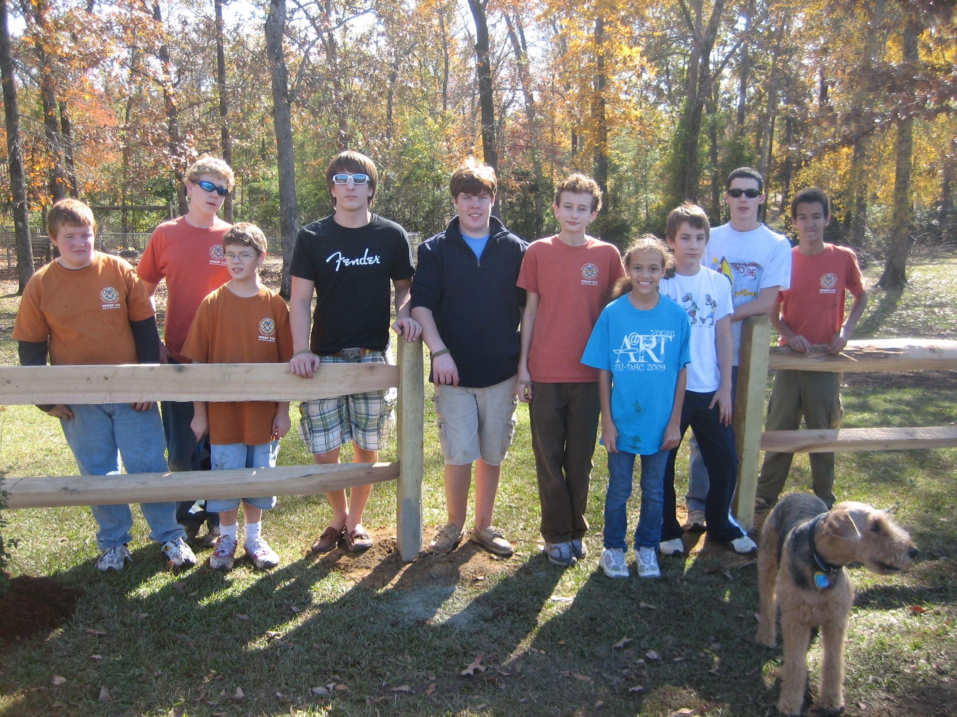

Eagle Scout Honor Roll – Troop 312
- James Gray 02-11-92
- Clayton Harbaugh 04-11-95
- Ryan Apollo Hardy 05-09-95
- Jonathan Wallace 11-14-95
- Ralph Hubert, Jr. 11-14-95
- Alexander Ford 02-13-96
- Erich Albert 08-13-96
- Davin Scott Wise 08-13-96
- Tony Benedetto 10-08-96
- Jacob Smith 02-10-96
- John Derrick 12-10-96
- Victor Kemper 09-09-97
- Blake Roy 02-01-98
- Ryan McGaughey 09-08-98
- Scot Oliver, IV 12-08-98
- Stancil Hood 03-09-99
- Matthew Mayer 03-09-99
- Jeremy Bouknight 02-08-00
- Craig Everett 01-09-01
- Nicholas Leitner 12-11-01
- Alexander Kloth 04-09-02
- Jonathan Mayer 05-14-02
- Roy West Talbert 11-12-02
- Thomas Chandler 12-10-02
- Ryan David Rucker 01-14-03
- Sean Ray Frady 02-11-03
- Samuel Ted Watts 03-11-03
- Jeremy Brice Law 04-08-03
- Ryan Joseph Wise 06-10-03
- Jeffrey Tillman McCraw 06-10-03
- Jason David Bebber 09-09-03
- Matthew Thomas Zion 10-14-03
- Phillip Kent Provence 03-11-04
- Stephen Kelly Soltis 03-11-04
- Gavin Daniel Richards 04-08-04
- Eric O’Neal Fockler 06-10-04
- David Alexander Donald 10-14-04
- Michael Clay Gantt 11-11-04
- William Davis Lee 12-09-04
- Lukas Maxwell Rennebaum 01-13-05
- Steven Matthew Harmon 06-09-05
- Michael Kent Bedenbaugh 08-11-05
- Andrew J. Blitch 05-09-06
- Louis O’Neal Clamp, III 08-08-06
- Cody Lawrence 08-08-06
- Blake Summer 08-08-06
- Mark Bebber 03/20/07
- Chip Bowman 03/20/07
- Tyler Andrew Cook 11/20/07
- Edward Whiteford Mungo 02/19/08
- Andrew Jennings Farr 07/17/08
- John Phillip Rusnak 09/16/08
- Thomas R. Yeoman 09/16/08
- Matthew Michael Barnes 02/17/09
- Kevin Carlton Kennedy 02/17/09
- Kyle Wilson Bedenbaugh 04/21/09
- Kyle Joseph Summer 08/18/09
- Mason Lewis Cannon 10/20/09
- Jesse Rees Richards 10/20/09
- Joshua Raymond Rennebaum 01/19/10

Boy Scouts of America

Troop 312

National Eagle Scout
Court of Honor

Joshua Raymond Rennebaum

March 14, 2010
2:00 PM
St. Simon St. Jude Episcopal Church
Columbia, South Carolina

Joshua Raymond Rennebaum

Boy Scouts of America, Troop 312

Eagle Scout Court of Honor
March 14, 2010

Presentation of the Colors……………….Troop 312 Color Guard

Pledge of Allegiance ……………………………………Ryan Smith
Senior Patrol Leader

Introductions……………………………………….…Mr. Tony Wise
Committee Chairman

National Court of Honor - Boy Scouts of America
Pastor Larry Hagerty, Pastor, St. Thomas Lutheran Church
Greg Lee, Eagle Scout and Scoutmaster
Jim Wallace, Scoutmaster Emeritus
Tony Wise, Troop Committee Chairman
Brian Cannon, Eagle Scout and Treasurer
Angela McGregor, Secretary-Troop Committee
Tony Bebber, Assistant Scoutmaster
Kent Bedenbaugh, Assistant Scoutmaster
Bryan Barnes, Eagle Scout and Assistant Scoutmaster
Richard Broughton, Eagle Scout and Assistant Scoutmaster
Neal Clamp, Chaplain and Assistant Scoutmaster
Robert Croom, Eagle Scout and Assistant Scoutmaster
Bill Harmon, Assistant Scoutmaster
Richard Hunton, Assistant Scoutmaster
Dru Kennedy, Eagle Scout and Assistant Scoutmaster
David Law, Advancements Chairman
Robert Heron, Eagle Scout and Assistant Scoutmaster
Jeffrey Ranta, Eagle Scout and Assistant Scoutmaster
Christopher Cathcart, Eagle Scout and Assistant Scoutmaster
Ken McGregor, Web Master
John Fletcher, Assistant Scoutmaster
Stan Lee, Assistant Scoutmaster
Tyler Cook, Eagle Scout and Assistant Scoutmaster
Varner Richards, Assistant Scoutmaster
Rick Rennebaum, Eagle Scout and Assistant Scoutmaster
Patrick McCawley, Assistant Scoutmaster

Acknowledgements

Josh gratefully acknowledges the following for their generosity
in contributing towards his Eagle Service Project and helping him attain the rank of Eagle:

- Members of St. Thomas Lutheran Church
- Mid Carolina Landscape Supply
- Great Southern Wood Preserve
- Hal Bickley and St. Thomas Church Committee
- BSA Troop 312 Scouts and Leaders
- Native Plants
- The Home Depot
- Indian Waters Council – BSA
- Etowah Creek district - BSA

Individuals:
Hal Bickley Chris Lindler
Mr. Brimm Kyle Martin
Langley Brimm Angela McGregor
Brian Cannon Carly McGregor
Kyle Cannon Jackson McGregor
Mason Cannon Collin McKinnon
Neal Clamp Josh Ranta
Carter Edenfield Lynn Rennebaum
Richard Hunton, Jr Rick Rennebaum
Richard Hunton lll Logan Shelton
Edward Izett Mike Shelton
Timmy Lee Ryan Smith
Carl Lindler Albert Stoudemire

Letters of Recommendation:
Mr. Gary Caudill
Mrs. Janis Morgan
Pastor Larry Hagerty
Sergeant Major (Retired) Armando Yturria

